- Run a command to show only the uptime duration and attach the screenshot.
# uptime

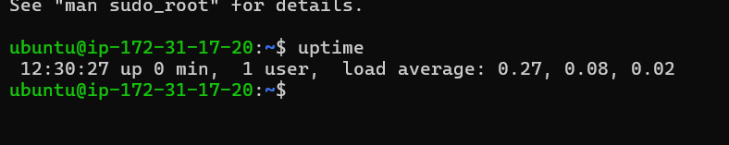
# uptime -p
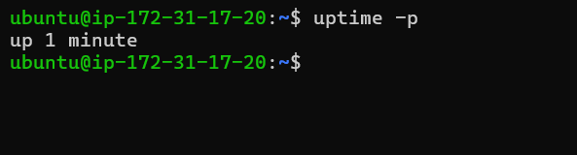
What is grep?
Ans :- The grep command in linux searches for specific text patterns in files.
1) Quickly find information without opening files
2) Filter logs and data files efficiently.
3) Automate text searching in scripts.
Example:-
# Find “error” in syslog file
grep “error” /var/log/syslog
Create a states file with names-

Andhra Pradesh, Sikkim, Madhya Pradesh, Gangtok, Arunachal Pradesh, Kerala, Uttar Pradesh, West Bengal, Nepal, Himachal Pradesh

using cat command.
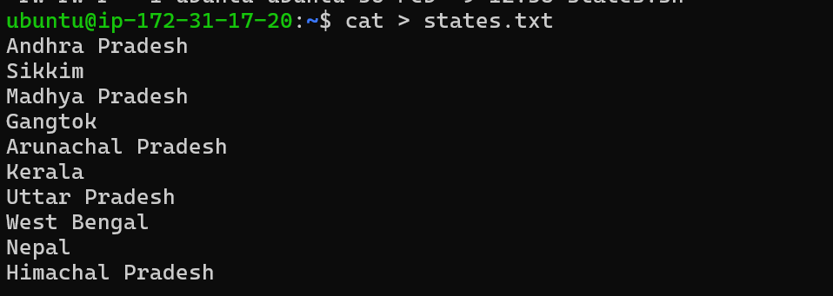
# find the word ""pradesh"" using grep on your terminal.
grep -i "pradesh" states.txt
2) Provide the screenshot of the output in terminal.
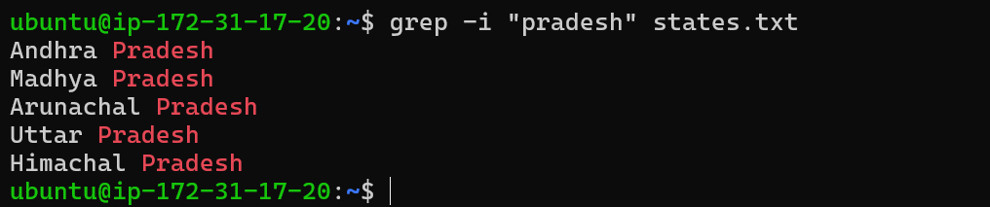
3) Differentiate between tail and syslog.
Ans:- Tail (Viewer) :- The tail command in linux displays the last few lines of a file.
It reads a file and displays the last 10 lines by default.
1.read the logs without opening the entire file
2.monitor file updates in real -time.
3.Extract the latest entries from large data files.
Syslog
Syslog is a standard logging system in linux that collect and stores logs from various system components.
1. Track user activities and system events.
2. monitor service failures and troubleshoot issues
3. Store logs in a centralized locations for analysis
Tail | Syslog
Type Command-line Tool | Type Logging system / service
Displays the last part of a file | Collects, processes, and stores system logs
Used to view log files or text files | Used to generate, manage, and route log messages
Common Command:  tail -n 10 Demo.log  tail -f /var/log/syslog | Common Command:  syslog, rsyslog
Real-time Monitoring (with -f option) | Real-time Monitoring (by logging events as they occur)

4) Can you run iostat command on your terminal without installing a package. Justify your answer.
Ans :-
No, you cannot run the iostat command without installing a package.
Justification: -
iostat is not a built-in shell command.
It is provided by the sysstat package on most Linux distributions.
If sysstat is not installed, the system has no binary named iostat, so the command will fail.

